Manual for
SeductiveApps
difficulty level : from just-new-to-webdesign to professional
by Rene AJM Veerman
<webappObfuscator-maintainer@seductiveapps.com>

Table of Contents
Table of Contents
Table of Contents 2
Scope 3
The learning curve 3
The pro developer’s setup 3
Software used for development and maintenance 4
Backups 5
Overview of the HTML, CSS and Javscript needed for a simple interactive web page 6
Examples that you can run in your browser 7
And relax about all the other languages used ;) 8
The sourcecode encryptor webappObfuscator and why the website template it encrypts “is so complicated” 8
Example 3 – adding PHP and splitting up the files for processing by webappObfuscator (among other things) 9
Example 2 vs Example 3 10
Example 2 – everything in 1 file 10
Example 3 – client-side code structured into multiple files 11
Example 3 – Serverside code also structured into multiple files. 12

Scope
I want to enable someone who is starting out with programming and specifically programming for the web to use this platform to create his/her very own first website, that can scale literally in any direction and length. Therefore professionals might wanna skip paragraphs that explain the basics.

The learning curve
Because webcoding is done in a rather large set of languages and libraries of code that you have to treat as a blackbox because it provides functionality to your software and thus can be considered sort of yet another language you’re using on top of the base languages (client-side : HTML, CSS, Javascript, canvas, webGL, and server-side : .htaccess, PHP, MySQL),
it can be said that the learning curve for webcoding is hard to get through, and at first, it is.
How you get around this is much like how kids learn to swim : the kiddie pool first, water to your ankles, then the shallow pool where you can stand and not need to swim to survive, and then the deep end pool. You don’t jump into the deep-end if you can’t swim properly in the shallow pool yet.
Translating that metaphor to webcoding; you don’t use more of each of the languages than you need to complete a webpage.
Specifically, you are best off sticking to just HTML, CSS and PHP first.
Next, you add some .htaccess (RewriteRule specifically) and/or some Javascript to your pages, to be able to learn these languages from simple examples to modifying more complicated examples.
Simply put, when learning webcoding you almost always use existing simple code-snippets (small example code that focusses on one or two aspects of the language) and modify those to do what you want to do in your website.

The pro developer’s setup
A website in essence runs on at least 2 computers (or one computer used both for editing and display of a website) : the server (i’ve chosen the versatile and widely supported PHP language for the server), and the client which is the webbrowser that runs on the same computer (during development on a devserver, which can be just an ordinary laptop running Windows, MacOS or the free Linux operating system (ubuntu.com is a good one)),
or you run that client set of code on another computer than the server to show the client part of the code.
It’s an industry standard (so unwise to deviate from) to have 2 sets of code, your devcode that runs on your devserver and in which you experiment and build new code etc, and your liveserver which basically can be an old machine that runs ubuntu, has the (google this : ) LAMP stack installed (Linux, Apache, MySQL, PHP) which includes the webserver software (Apache), a versatile good SQL database solution called MySQL and the webcode language PHP to glue it all together to produce output that runs in the client webbrowser (in the HTML, CSS, Javascript languages (that’s the scope of what you receive in the webappObfuscator package) and possibly augmented by you with the canvas (2D advanced graphics, connecting to the webcam of the enduser’s webbrowser) and/or the webGL languages (webGL provides 3D graphics but is still under a lot of initial development, see scenejs.org if that’s still around).
Your devserver can and should be your devclient, and on your liveserver you preferably don’t run anything experimental.

Software used for development and maintenance
Server (on a PC or MacOS desktop machine) | Operating System Linux  recommended : http://ubuntu.com | - How to install LAMP stack
Server (on a PC or MacOS desktop machine) | Operating System Windows  http://windows.com | - Install http://wampserver.com/en
Server (on a PC or MacOS desktop machine) | Operating System MacOS  http://apple.com | - Howto install Apache, PHP and MySQL on macOS
Development Editing Machine (might be the same machine as the server, or the same as the client, or an entirely different machine) (I recommend windows networking to connect to servers from the development editing machine, or an FTP(S) client as second choice). | Operating System Linux | - Install code editor : kate
 | Operating System Windows | - Install code editor : notepad++
 | Operating System MacOS | - Install a code editor
Client | Operating System Linux | - Install Firefox web-browser on Ubuntu  - Install Chrome web-browser on Ubuntu
 | Operating System Windows | - Install Firefox web-browser on windows  - Install Chrome web-browser on windows  - Internet Explorer web-browser by Microsoft
 | Operating System MacOS

Backups
You have to backup your devcode regularly, every day worked on it and not backed up is a day sorely missed when you have to retype code that you might lose in a crash or intrusion (when you possibly get hacked and your code stolen and the deleted off *your* server – it’s just another form of theft).
You backup into *.rar archives and PUT A LONG STRONG PASSWORD on that archive. RAR is available for all operating systems without cost and the encryption strength can be trusted (industry standard, same quality as https I think).
But backing up regularly, like everyday or multiple times per day, is not recommended either. The backup device itself (I recommend sturdy USB keychain drives) will wear out and when you least can use it, will give you a hardware failure from over use.
You basically backup whenever you’ve added significant value in the form of new code / documentation / artwork. You ESPECIALLY backup, maybe for a few days even multiple times per day, when you’ve added code that you know / suspect is hard to recode later from memory in case of a total crash.

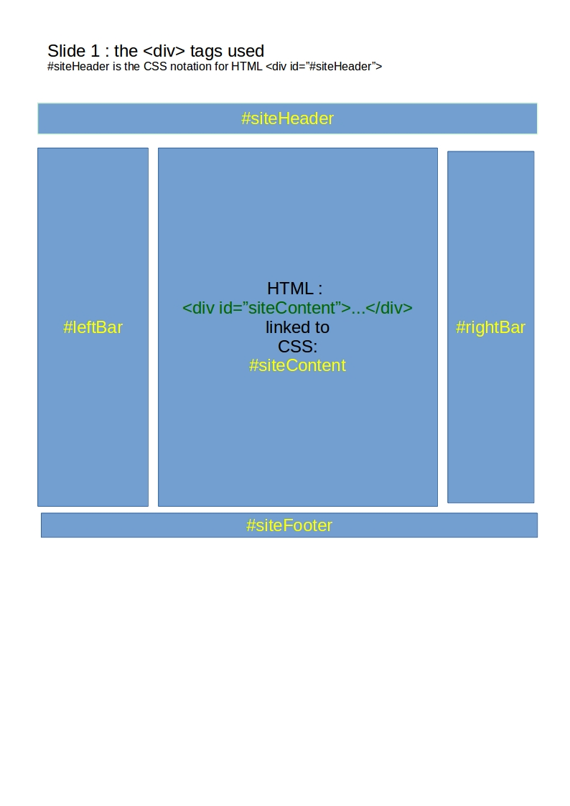
Overview of the HTML, CSS and Javscript needed for a simple interactive web page
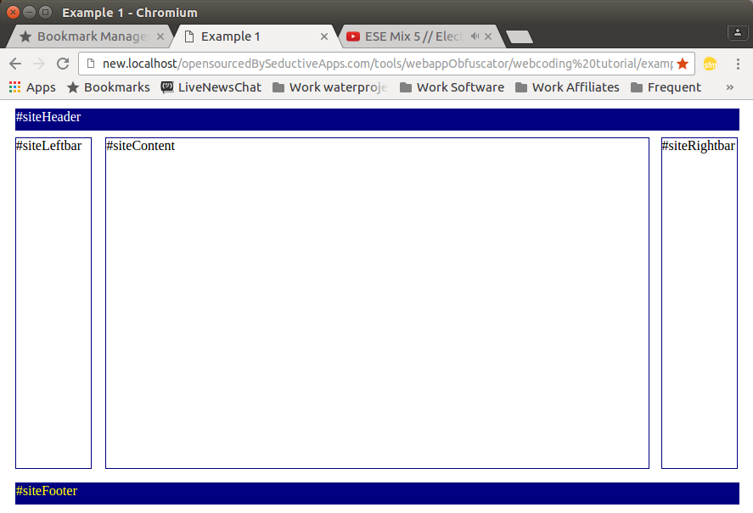
I can’t make this manual too large by explaining the most basic skills of web programming to you in this manual. I refer beginners to the front page of http://w3schools.com for you to understand the basics of the languages used in the web-browser on the client-side. And w3schools remains a useful reference for professionals too.
Beginners, please read and understand the link between HTML and CSS exlained in this article (html attribute : id=”#someID”) and this article (html attribute : class=”abc xyz”).

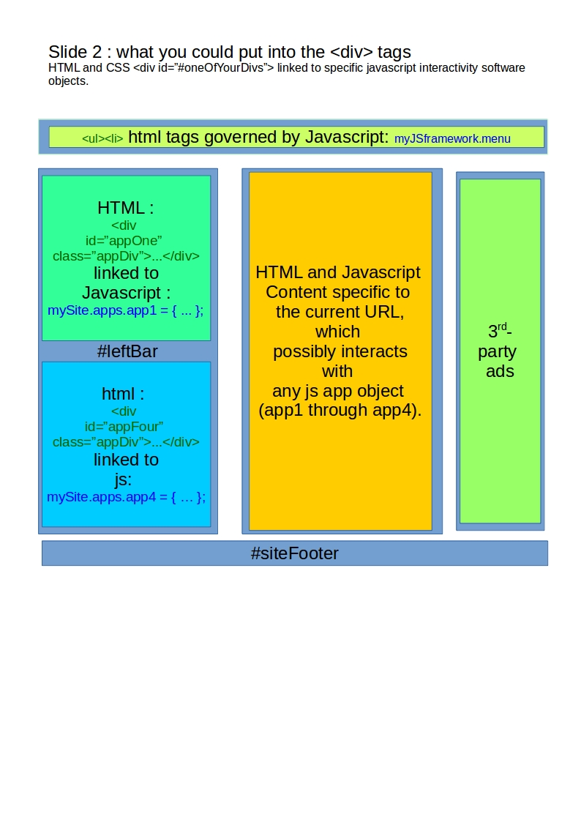
Examples that you can run in your browser
You can find example PHP files in the examples folder under the folder where you found this file that you’re reading now.
Copy this examples folder in your webserver root folder (also called your htdocs or www folder) and open them in an internet browser.
Your webserver root folder is located on Linux in /var/www/
and on windows in C:\wamp\www
You can then browse to http://localhost/examples to view them in the browser.
Example 2 uses the http://jquery.com library, and while there are alternatives to jQuery in these examples we’ll be using jQuery.
I strongly recommend you play with a copy of each these examples and use them to learn about the other settings of the languages used with the help of http://w3schools.com

And relax about all the other languages used ;)
The languages Canvas (2D advanced graphics and things like connecting to the webcam of a user) and webGL (3D graphics), you can learn about after learning about PHP, HTML, CSS and Javascript. Canvas and webGL are both controlled by javascript and are embedded into HTML and possibly CSS as well.
These tutorials are limited to understanding HTML, CSS and Javascript and all that is necessary on the server end to make that work on the client-side, and only so much of each language to get done what you (or the example) wants to get done.

The source-code encryptor webappObfuscator and why the website template it encrypts “is so complicated”
webappObfuscator, in a nutshell, replaces the vast majority of your own variable names and function names with 3-letter random strings, and concatenates where-ever useful many source-code files into single file(s) to reduce the load-time of your live site. A string is a word or a sentence, possibly mixing in other characters as well.
However, it is within the scope of the webappObfuscator project to facilitate a rich interactive website framework that is a bit more advanced than just a PHP file that spews out HTML.
In particular, I want to use the HTML history API (Application Programmer Interface) to prevent the screen blinking to all white during URL changes (URL = what’s in the location bar of the browser), and to make the website a fully AJAX-driven and javascript controlled thing in which sections of the page are driven (or not) by compartmentalized javascript software objects.
A software object consists of both variables (data storage) and functions (programming code) and ofcourse other objects.
The website template that webappObfuscator provides is as complicated as it is so that you don’t have to start from scratch if you want to expand upon an earlier website template design of your own.
The examples provided all get increasingly more complicated until you end up with the website template that webappObfuscator works on as part of it’s distribution package.
The website template gets even more complicated because you need to be able to run the unencrypted sources and you’d want to keep those sources well protected even on the live-server so that you can test on platforms that you don’t own hardware for. I for instance am a windows and linux man, and I really dont want to spend money on MacOS / iPhone hardware (let alone pay for each new versions of those things). So I end up going to a Apple Store to test my software on their products on display, and being able to access the actual source-codes (and client-side console log) is key to fixing bugs that only show up on specific browser platforms.

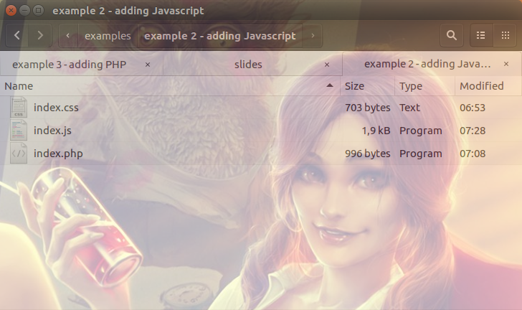
Example 3 – adding PHP and splitting up the files for processing by webappObfuscator (among other things)
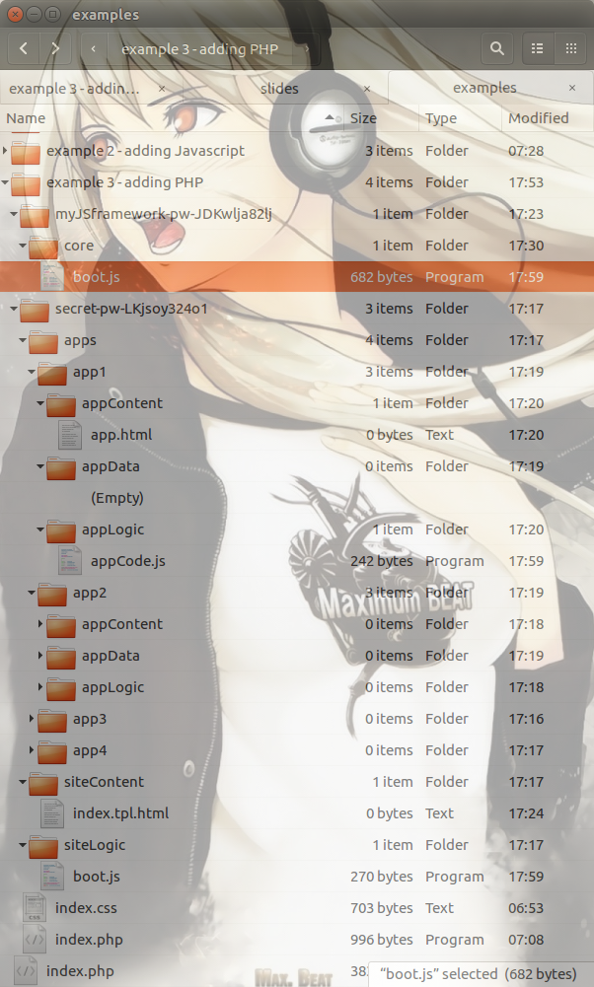
For a site template that doesnt actually do anything (or not much), the structure of example 2 is sufficient.
Creating a site that “does actual work”, and thus the minimum requirement for a site that is webappObfuscator compatible, starts with a server folder-structure like shown here in example 3.

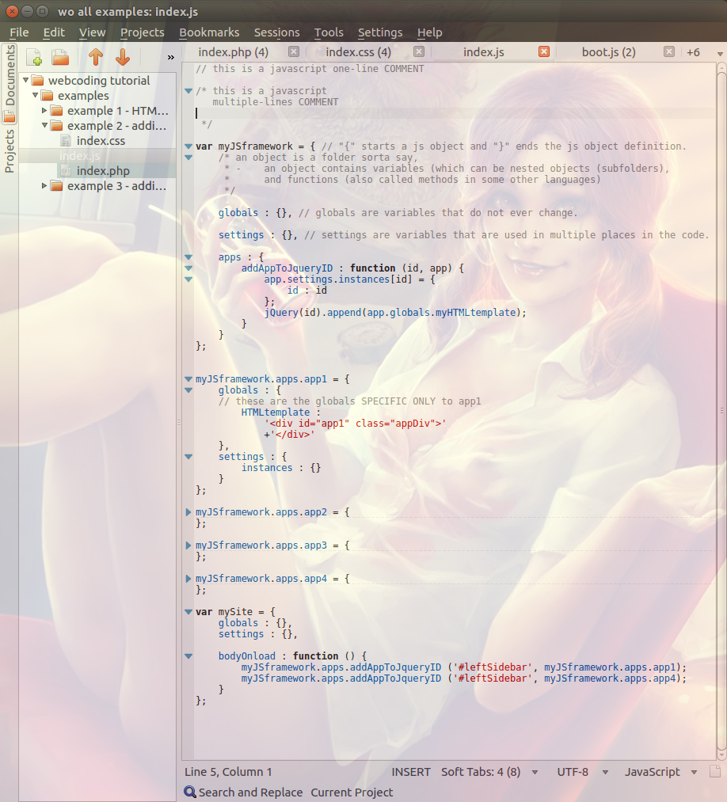
Example 2 vs Example 3

Example 2 – everything in 1 file
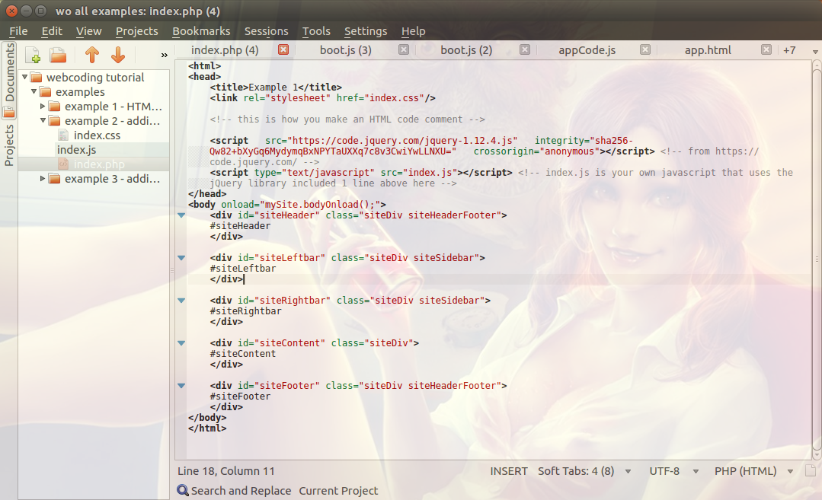
The .../index.php for example 2 can output only basic HTML needed to include just 1 javascript file, with all of the javascript for entire site in …/index.js for example 2, as shown to the right here.

Example 3 – client-side code structured into multiple files
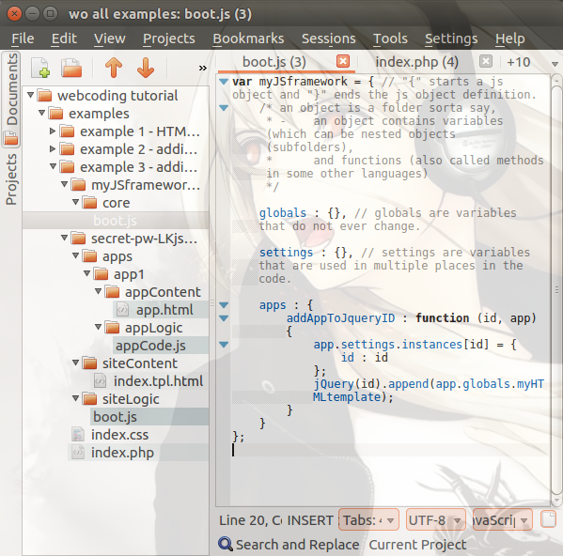
…/myJSframework-pw-(PASSWORD)/
core/boot.js is now cut down to just what’s needed in javascript to add multiple polymorphic (the same or very likewise in code structure) apps’ javascripts.

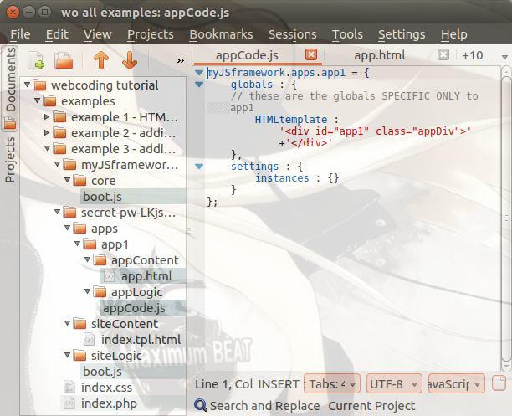
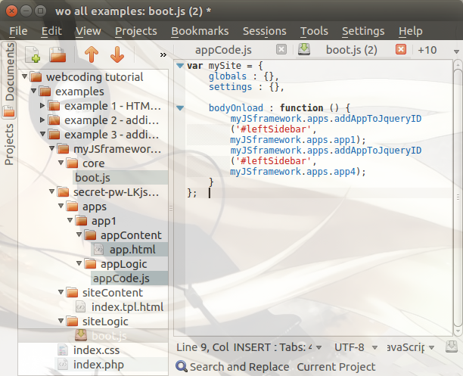
…/secret-pw-(PASSWORD)/
apps/app1/appLogic/appCode.js contains all the code for app1, shown below here..
The code for app2, app3 and app4 is polymorphic which means it at least answers to a common set of functions and variables as are used in all apps javascript. Only the most basic app1 code is shown here.
…/secret-pw-(PASSWORD)/
siteLogic/boot.js holds all of var mySite which will govern the website as a whole, regardless of what URL the visitor is on at the moment.

Example 3 – Serverside code also structured into multiple files.
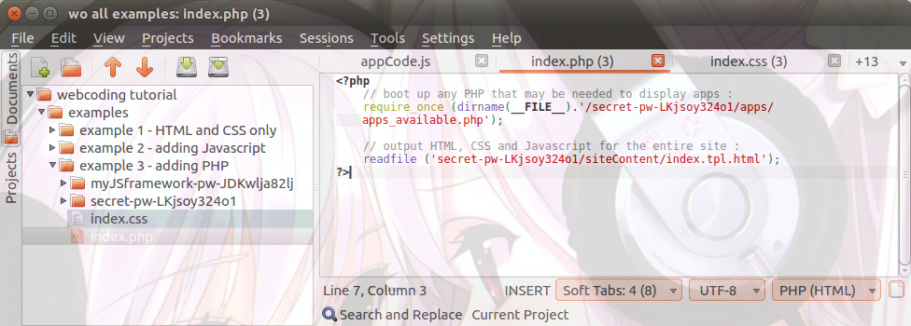
…/index.php changes to not output the HTML for the site, but read in a template file and push that to the browser instead..
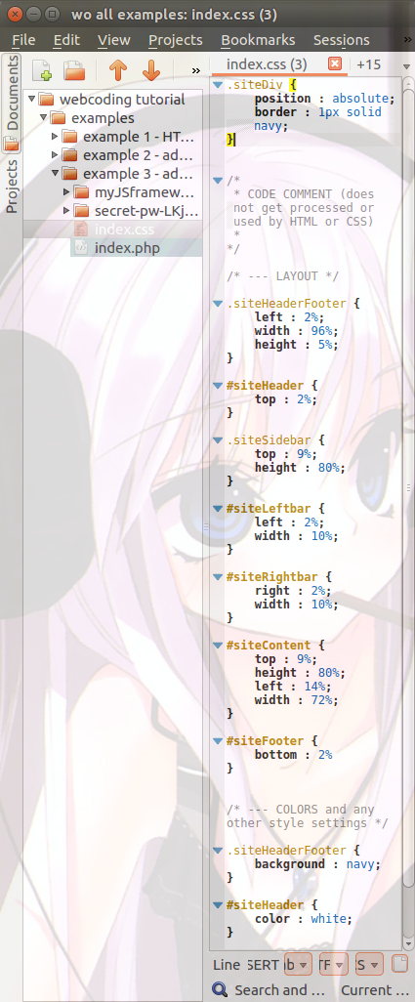
…/index.css is a file that (at this point at least) does not get split up into multiple files. Sometimes it’s better to have all settings for a site in 1 file, or things get too difficult to keep track of.
…/secret-pw-(PASSWORD)/
apps/apps_available.php is the index file for all the apps you currently want loaded into the …/index.php variables namespace.
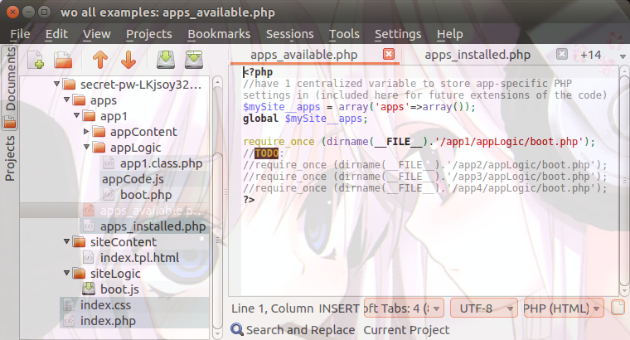

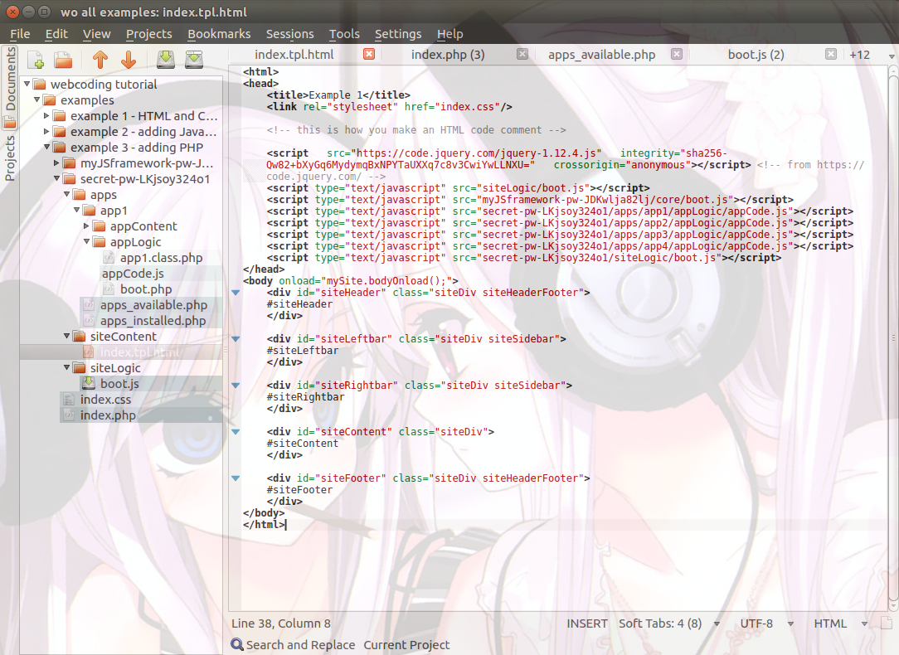
…/secret-pw-(PASSWORD)/siteContent/index.tpl.html is now read by …/index.php and contains (for this level of difficulty in example 3) all the HTML and CSS and Javascript calls needed to make the site work.
The environment for javascripts
There are a few ways to make javascripts work in the browser, and you basically have to pick one of these ways and stick to that in order to keep your website understandable and upgradeable.
I use an approach that uses the window namespace in javascript to host a hierarchal namespace for all the components you have on a page, both visible and invisible components.
Apps and their influences on the browser-end
Apps get loaded into #siteContent and see any javascript they bring along loaded and/or executed on loading the app.
Example 4 – plugging in the rest
We need end-users able to put a certain URL (address) into the browser and show a specific page (specific content) based on that URL.
While http://mysite.com/ would show the front page for your website, http://mysite.com/appOne/appSettingA/appSettingB would need to load the appOne main content into #siteContent, and custom ads for appOne into #rightBar
a .htaccess file is the traditional way to solve this problem. It translates a regular expression (regexp) into a url like index.php?app=appOne&appSettingA=something.
Index.php and any other PHP files that index.php calls, are able to access that information via the $_GET built-in array; $_GET[‘app’] == ‘appOne’.
The information you can include in a URL is limited, or you end up with extremely long URLs.
And yet, by changing URLs, you should be able to load up multiple parts of an app that reside in different DIVs in the browser.
And we also need to keep the browser’s forward and backward button functionalities intact.

